
PERTH COLLEGE

Trial Western Australian Certificate of Education

Examination, 2010

Question/Answer Booklet

MATHEMATICS
If required by your examination administrator, please place your student identification label in this box

3C/3D

Section One:

Calculator-free

Student Number: In figures

In words

Time allowed for this section
Reading time before commencing work: five minutes
Working time for this section: fifty minutes

Material required/recommended for this section

To be provided by the supervisor
This Question/Answer booklet
Formula sheet

To be provided by the candidate
Standard items: pens, pencils, pencil sharpener, eraser, correction fluid/tape, ruler, highlighters

Special items: nil

Important note to candidates

No other items may be used in this section of the examination. It is your responsibility to ensure that you do not have any unauthorised notes or other items of a non-personal nature in the examination room. If you have any unauthorised material with you, hand it to the supervisor before reading any further.

Structure of this paper

Section | Number of questions available | Number of questions to be answered | Working time (minutes) | Marks available
Section One:  Calculator-free | 9 | 9 | 50 | 40
Section Two:  Calculator-assumed | 12 | 12 | 100 | 80
 |  |  |  | 120

Instructions to candidates

- The rules for the conduct of Western Australian external examinations are detailed in the Year 12 Information Handbook 2010. Sitting this examination implies that you agree to abide by these rules.

- Write your answers in the spaces provided in this Question/Answer Booklet. Spare pages are included at the end of this booklet. They can be used for planning your responses and/or as additional space if required to continue an answer.
- Planning: If you use the spare pages for planning, indicate this clearly at the top of the page.
- Continuing an answer: If you need to use the space to continue an answer, indicate in the original answer space where the answer is continued, i.e. give the page number. Fill in the number of the question(s) that you are continuing to answer at the top of the page.

- Show all your working clearly. Your working should be in sufficient detail to allow your answers to be checked readily and for marks to be awarded for reasoning. Incorrect answers given without supporting reasoning cannot be allocated any marks. For any question or part question worth more than two marks, valid working or justification is required to receive full marks. If you repeat an answer to any question, ensure that you cancel the answer you do not wish to have marked.

- It is recommended that you do not use pencil except in diagrams.

Section One: Calculator-free (40 Marks)

This section has nine (9) questions. Answer all questions. Write your answers in the space provided or on the spare pages included at the end of this booklet.

Working time for this section is 50 minutes.

Question 1 (4 marks)

Determine 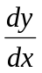 for the following functions:

(a) 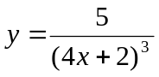 (2 marks)

(b) 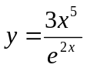 (2 marks)
Question 2 (3 marks)

R and S are events where P(R) =, P(S) = , and P(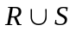) =.

- Find P(S|R). (2 marks)

- Are R and S independent? Give a reason. (1 mark)

Question 3 (3 marks)

Determine the gradient of 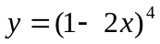 at the point (1, 1).

Question 4 (5 marks)
A function is defined by the rule y = f(g(x)), where f(x) =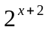 and g(x) =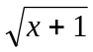.

- Determine the domain and range of:

  - f(x) (2 mark)

  - f(g(x)) (2 marks)

Should have been (0,8)

(b) Without substituting any values in f(g(x)), determine whether or not the point (0,1) lies on the curve defined by f(g(x)) and justify your answer. (1 mark)

Question 5 (5 marks)

Solve the inequality below:

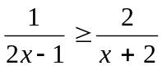

Question 6 (4 marks)

(a) Determine the indefinite integral: (1 marks)

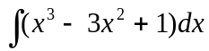

(b) Evaluate the definite integral (in terms of e): (3 marks)

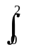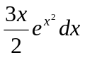

Question 7 (5 marks)

Solve the system of equations by elimination:

2x + 3y – z = 15

4x + 5y + 2z = 4

2x – 4y – 3z =13
Question 8 (3 marks)

The graph of the hyperbola y = 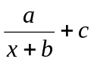 is shown below. The point (-3, 2) lies on the curve, 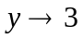 as x 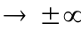 and 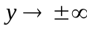 as 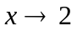.

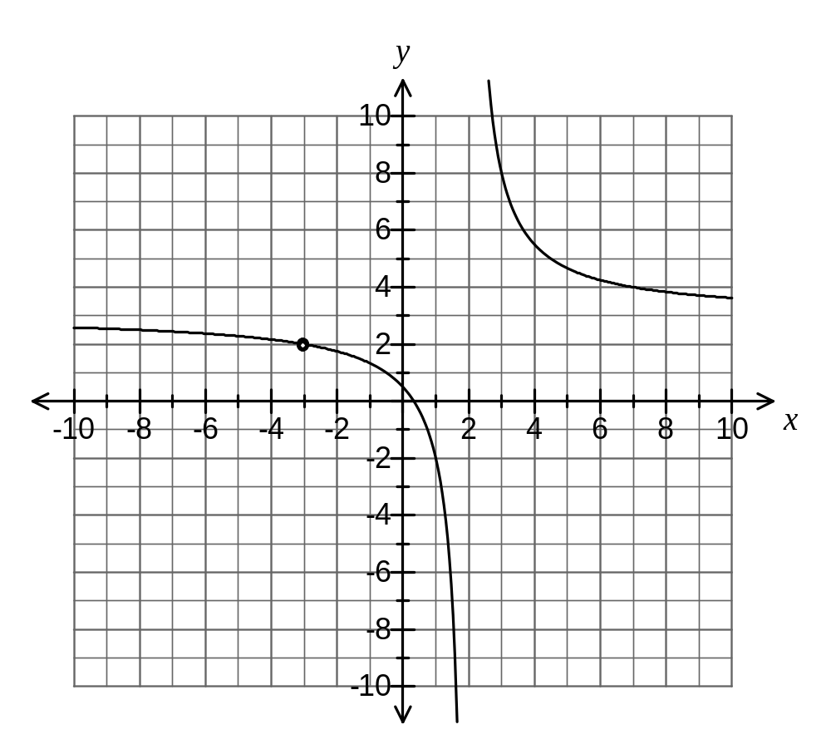
Evaluate a, b and c showing any working.

Question 9 (8 marks)

On the axes below, sketch the function f(x) = x³ – 9x² + 15x + 25 showing any turning points, points of inflection and intercepts on axes.
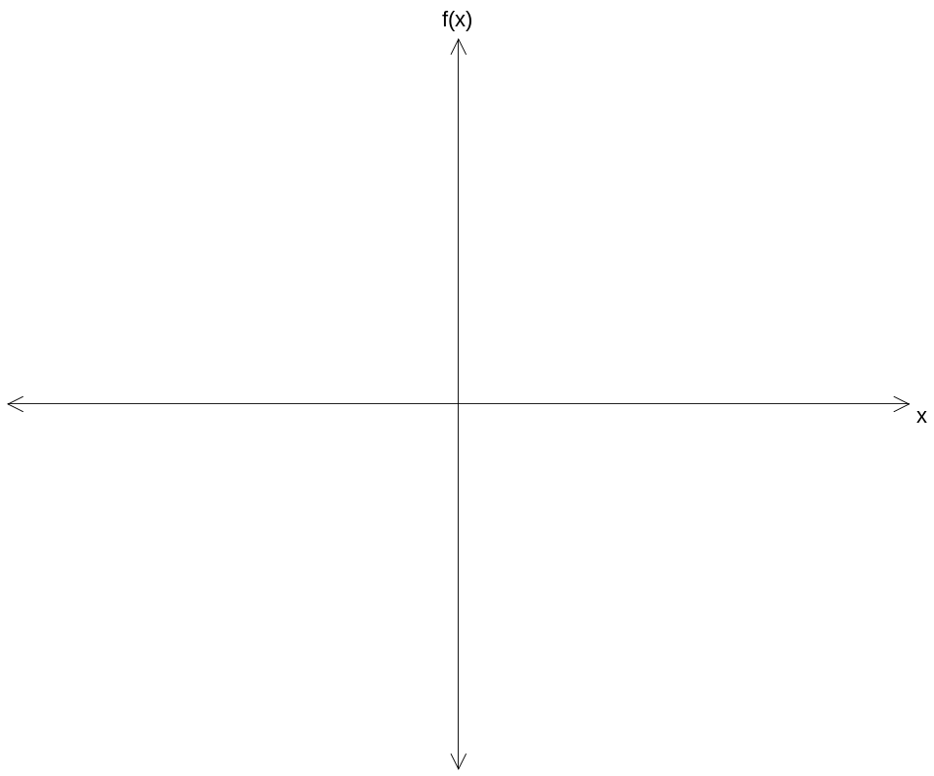
f(x)

Additional working space
Question number(s):

Additional working space
Question number(s):

Question Number | Available Marks | Your Mark
1 | 4
2 | 3
3 | 3
4 | 5
5 | 5
6 | 4
7 | 5
8 | 3
9 | 8
Total |  | 40

